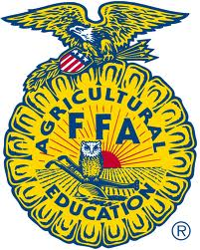
Brighton FFA
Truck & Tractor Pull
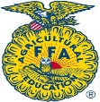
Brighton, TN
August 16, 2013 7 P.M.

Presented by:
United States
Pullers
Association

CLASSES
Super Farm
Super Stock
Pro-Stock Diesel
Street Diesel

½ Page Ad

Full
Page
¼ Page Ad
Ad
1/8
Page Ad

